**Investor obtain U.S. Citizenship**

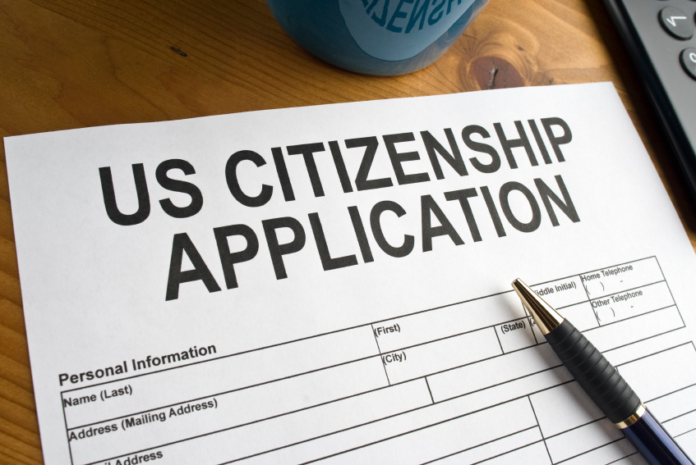

**Permanent Green Card issued to investor**

**File appeal with USCIS or abandon case & apply for another immigrant visa**

**CASE DENIED**

**Immigration attorney files from I-829 to remove temporary conditions from Green Card**

**Conditional Green Card issued to Investor (2) years**

**I-526 APPROVED BY U.S.C.I.S. IN 8-9 MOONTHS**

**Immigration Attorney works with RC & Investor to prepare and file U.S.C.I.S. Form I-526 along with required documents/information**

**Investor deposits $500,000 Capital Contribution & Administration Fee of $35,000 to $55,000 in to RC**

**Investor signs documents issued by RC: Private Placement Memorandum, Subscription Agreement, Limited Partnership Agreement, and Escrow Agreement**

**Investor contacts International Tax Attorney for pre-immigration Tax Planning**

**Investors contacts Immigration Attorney to review RC documents**

**INVESTOR CHOOSES REGIONAL CENTER (RC)**